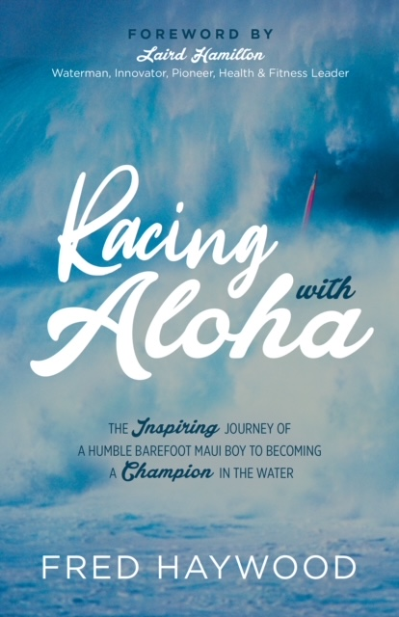
Sample Chapter
RACING WITH ALOHA

The Inspiring Journey of a Humble Barefoot Maui Boy
to Becoming a Champion in the Water

By Fred Haywood
Foreword by Laird Hamilton

Ho’okipa
I had just set the windsurfing world speed record in 1983, breaking the thirty-knot barrier in Weymouth, England, but that’s not how I made my name in the sport. My fame came on a day when I was surfing alone, thanks to an eccentric and very wealthy fellow windsurfer and cover photographer for such magazines as Vogue and Life, who showed up to watch me after everyone else had left the beach for the day.
One morning, I was driving along Hana Highway on Maui when I could see Arnaud de Rosnay cruising toward me in his convertible.
“Hey, Fred!” he called.
Waving wildly, he stopped me on the road, and we chatted while our cars idled. In those days on the island, traffic was light, and we could sit there for several minutes without worrying about blocking traffic.
Arnaud was dressed all in white, his long hair blowing in the breeze. Before the end of the year, the dashing and wealthy French baron would disappear, attempting to windsurf across the South China Sea’s one-hundred-mile Taiwan Strait. But on this particular blustery spring day in 1984, Arnaud was eager to photograph what he claimed would be the best day to surf the north shore of Maui.
“The biggest waves in the world will be coming in at Ho’okipa today. I’ll be there at noon with a helicopter to shoot it. Come sail at noon!”
“Yeah, I know,” I said to him. “But I’ll be there at three. I’m going to sail a really big wave at around four o’clock, maybe four-thirty.”
“But I’ll have the helicopter there at noon!” Arnaud insisted.
“I’ve been sailing every day,” I told him, “and every day, the big waves have been coming late. The biggest set of the day will come around four. I don’t want to sail until it’s going to get really big. I think someone is going to ride the biggest wave in the world, and I want to be the one.”
It was an exciting time to be surfing on Maui. Matt Schweitzer, Mike Waltze, Pete Cabrinha, Malte and Klaus Simmer, Dave Kalama, Laird Hamilton, Craig Masonville, Robbie Naish, Greg and Alex Aguera, Vince Hogan and I were experimenting and innovating with our boards on the water. We weren’t the first to do anything, but we convinced those who were that Maui was the place to push their limits. They came. They pushed. And windsurfing took off, followed by big wave tow-in and paddle-in, stand-up paddling, kite sailing, and foil-boarding. Maui offered the stage that showcased the stars.
I have lived on Maui my whole life. I know the water. I know the waves. I knew Ho’okipa, a beach that offers some of the biggest challenges for board surfing in the world but was pretty much a secret in the early eighties.
I showed up at three o’clock to find David Ezzy, Malte Simmer, Mike Eskimo, and Craig Maisonville there, and so was the helicopter. I stood on the beach to watch Malte Simmer going up to face a wave, making a turn at the top, and coming back down.
The waves were huge, indeed. The faces were maybe forty or fifty feet—the hugest I had ever seen at Ho’okipa. I started to second-guess myself. I wondered if I had misjudged the best time to be on the water. I rigged up to sail out on a 5.9-square-meter sail with a seventeen-foot mast—a big rig for my windsurf board, which was a can-opener style.
I tried to sail out, but I had to push over whitewater twice as high as my mast, and a few threw me back. It took me thirty minutes to cover what should have taken me thirty seconds—if I hadn’t kept getting blasted by the waves. When I finally got outside, the wind suddenly dropped. It was late. I looked left and right, and I saw nobody. The helicopter was gone. Everyone had gone in.
“Okay. Oh, well,” I said to myself. I hadn’t come for the helicopter. I just wanted to surf the world’s biggest wave that day.
And then I did.
I waited for what seemed like forever for that wave. It wouldn’t come through. I took a few, but the waves weren’t that big. I kicked out to look for it.
And then I saw out in the distance, a mile or two away, a wave that was standing some twenty feet above the others. That was it. This was the tide change. By the time the wave caught me, I was hydroplaning. The wind was turning more offshore now, and I was going almost straight upwind. To drop in, I had to veer off to the right and slide across the wave.
I got to the top and looked down—I must have been six stories high. I took the power in my hands, and I zipped down the face. I ran out on the flat, trying to get in front of it. I didn’t know when it would break.
All of a sudden, the lip of that wave came over and crashed right on my tail block. I almost ditched my rig, but I held on by my fingertips. It didn’t hit me. There was whitewater all around me. I hung on my boom. A moment later, I caught a blast of wind from the collapsing wave and started sailing. It took me back to land and pushed me right up to the dirt bank at the back of the beach.
I lay there, taking it all in.
I did it, I thought. And then, as if I had spoken out loud…
“You did it!” I heard someone holler. “Fred! YOU DID IT! You surfed the biggest wave in the world!”
It was Arnaud. I looked up to see him running toward me through the sand with a camera bouncing around his neck. Everyone else had left. But not Arnaud. Arnaud was a real pro, both on the water and behind the lens. He would never miss the wave—or the shot.
“I got it!” he exclaimed. “I shot a whole roll of film on one wave. You are going to be famous! These pictures will make you even more famous than breaking the world record!”
Arnaud was right. I made all the top trade magazines. But the one that put me on the map was Life magazine. In 1984, Life was widely admired by a broad general audience for its photojournalism.
Arnaud’s photos won me a windsurfing sponsorship, launching my professional career in speed sailing and earning me sponsorships for nearly a decade. Not bad for a boy who grew up on the beaches of Maui and went to grade school barefoot.
My love of the water started when I was baptized, figuratively speaking, in Kahului Harbor at the age of seven.

